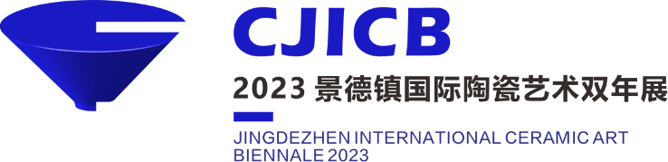

“瓷 的 旅 程”——
2023景德镇国际陶瓷艺术双年展作品报名表
The Journey of Ceramics: 2023 Jingdezhen International Ceramic Art Biennale, Application Form

个人照（建议以工作室为背景。大小：5MB以下）  Portrait photo  (Better take photo in your studio, files must be 5MB or less.)，5cm × 5cm |  |  | 姓Family Name |  | 名First Name
 |  |  | 出生年Year of Birth |  | 性别 Gender
 |  |  | 国籍 Nationality |  | 现在的职业 Current Occupation
 |  |  | 地址及邮编 Mailing Address/Post Code
通讯资料  Contact  Information |  |  | 国家编码National Code | 地区码Area Code |  | 号码 Number
 | 电话 Tel ( H )
 | 手机 Mobile
 | 电子信箱E-Mail
简历：教育经历、获奖经历、收藏等(10条以内)
Curriculum Vitae：Education, Awards, Collection, etc.(Within 10 Lines)
教育Education | 年份year | 系科course of study‧学校institution‧城市city‧国家country
展览 Exhibition | 年份year | 展名title of exhibition‧地点venue‧城市city‧国家country
获奖  Awards | 年份year | 奖项name of award‧竞赛title of competition‧地点venue‧城市city‧国家country
收藏 Collection | 年份year | 作品名name of collection‧地点venue‧国家country

作品名称
Title of Work
作品类别  Type of Works | 陶瓷器皿Ceramic Vessels□ 陶瓷雕塑Ceramic Sculptures□ 陶瓷绘画Ceramic Paintings□  陶瓷装置Ceramic Installations□ 陶瓷影像Ceramic Videos□
材质
Materials
技法
Techniques
烧成温度 (℃)
Firing Temperature
创作年份
Year of Creation
尺寸  Dimensions | □ 单件 宽(cm) 深(cm) 高(cm) 重(kg)  Single Piece Width Depth Height(cm) Weight  □ 套/组 件数 重(kg)  Set Number of Pieces Weight(kg)  最大组件 宽(cm) 深(cm) 高(cm)  Maximum Width Depth Height(cm)  装置尺寸 宽(cm) 深(cm) 高(cm)  Installation Width Depth Height(cm)
展览要求Exhibition requirements | 展台Pedestal□ 挂墙Wall hanging□ 落地摆放Floor placement□ 其它others□
作品介绍Statement to the work ( 150字以内\Within150 characters )
请粘贴参赛作品正面照片1张。Please affix a photo of the work you wish to submit（front）.
请粘贴参赛作品照片侧面或者局部1-2张。Please affix 1-2 photo of the work you wish to submit（side or part).
请粘贴参赛作品照片侧面或者局部1-2张。Please affix 1-2 photo of the work you wish to submit（side or part).

★报名期限：2023年8月15日24时截止(北京时间)。
Application Deadline: PM 24:00, August 15,2023 (GMT +8).
注：
1、请提供个人照电子档 Please offer the artist portrait in digital format (3MB or more).
2、请提供参赛作品照片3至5张，每张尺寸要求像素大于300dpi,大小为5-10M ，Sublimation Works image 3-5 Pics (each more than 300dpi, 5MB-10MB).

